IT with Doug

If you have a USB drive you can spare, you should do this now: <https://ubuntu.com/tutorials/create-a-usb-stick-on-windows#1-overview>

If you’ve already got that far then try to get Python and PostgreSQL installed

<https://docs.google.com/document/d/1GQBiALk0im8unwks56VBkVzcdYXnLkT5IKBCRv-QGSc/edit?usp=sharing>

You should install this: <https://ubuntu.com/wsl>

Also you should buy yourself a Raspberry Pi. You can set it up to block all ads on your home network, which is useful and also a good exercise in configuring a linux system to do something useful

Add these to your list in case they're not already there: <https://www.redhat.com/sysadmin/7-great-network-commands>

Some basics about networking you should know <https://www.howtogeek.com/341307/how-do-ip-addresses-work/>

I say get the version 4, or any version that has both wired and wireless networking. Then you can plug it into your router and use the wireless chip to set up a wiki hotspot that does cool shit like scrub the ads out of every website you visit

You can also scrub any sort of tracking code

For example any page that has a Facebook like button on it sends your activity to Facebook so they can use it to augment the profile they have on you

You can also install a vpn on the pi so even when you’re not home, your phone will toute all your network traffic back through the pi and you get all the same protections

My point is get a pi with two networks interfaces and you can learn Linux and put what you learn to practical use

No soldering iron yet, maybe later we’ll get you an arduino and do some electronics stuff

Strictly speaking you don’t need the hdmi cable either but I guess it’s useful to get started

Setting it up headless is a good challenge though

Well you could say that the only difference between a desktop computer and a server is whether or not you plug in a screen and keyboard

So if you manage to get your raspberry pi up and running without using a screen you could maybe add server administration to your resume Meanwhile, programming

<https://adventofcode.com/2020>

I'd like to see you do that series of problems in python

Cause I already did it in python so I have notes and I can help you easily

Also, make yourself an account on github.com

Then you can learn git while you program, and use it to share your code with me

we'll get two birds stoned at the same time

WilliamHW

Now <https://github.com/new>

I'm refreshing your profile page waiting for a repository to appear

It's called ITwDoug

How do I like "install" python.... what's a windows code writing 'forum'. Je pars de loin... 😅

You could start by doing the first couple in colab.research.google.com

That way you can get to coding and worry about installing shit later on

Things like Python and git are easier to install and update in Linux

In Ubuntu you can install python by opening a terminal and running "sudo apt install python"

For git you run "sudo apt install git"

To get a better guided introduction to python you can start going through this: <https://www.learnpython.org/>

It explains all the concepts and lets you fuck around with code examples in your browser

At least read the first advent of code challenge, then when you feel like you've gotten enough from learnpython.org to solve it, do it in colab

Each challenge gets harder so it will give you reason to read more of learnpython

once you've done a couple of challenges we'll come back to installing python and git

<https://github.com/WilliamHW/AdventOfCode2020/new/main>

You're not going to be able to run your code from within github itself

To do that you'll want to clone the repository onto your local machine

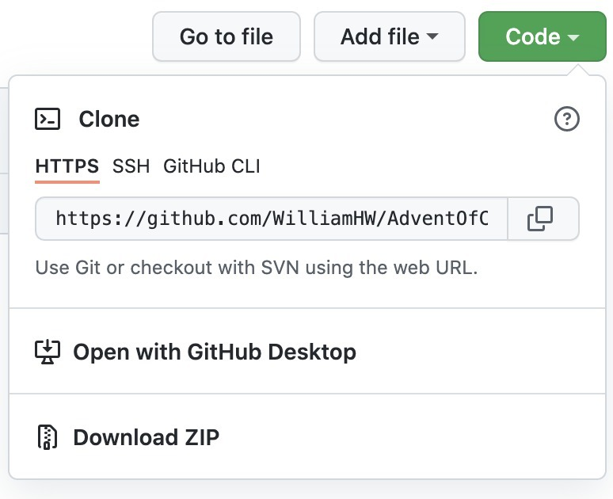

Click on the code button in your repository and copy the https string

Then from a terminal, in your home directory, run 'git clone <https://github.com/WilliamHW/AdventOfCode2020.git>'

You will need to have already installed git with 'sudo apt install git'

"git clone" will copy the repository into a new directory. See it with "ls", then enter it with "cd AdventOfCode2020"

(something you'll notice over time is that linux people aren't big fans of capital letters, because linux is cases sensitive. But it's fine)

Then, assuming you have already installed python (sudo apt install python3), you can run your script with "python3 Day1"

It will complain about the last two lines, because those aren't valid python, they're more of an example of how to use the script

How much of that script do you understand?

<https://www.youtube.com/watch?v=THNPmhBl-8I>

Your x.py file you can equally run from a terminal using the command "python3 x.py"

python is a dynamic language, so it gets compiled at the moment you run it. A separate compilation step isn't necessary

For now I'd say go through everything under "Learn the Basics" on learnpython, at least as far as loops

Between loops, conditions, lists and basic operators you should have everything you need to solve the first challenge

That script uses some clever tricks that might make the code a bit more concise but that also make it harder to understand

I'm working on something that will make it easier to load the puzzle input into your script but something's fucky, might not have it ready for you tonight

Something like this? <https://github.com/benediktwerner/AdventOfCode/blob/master/get_input.py>

Very similar to that. But that one doesn't work either, it has the same problem mine does

That approach used to work, but they must have changed something on the website and now it doesn't recognize you as logged in based on your cookie

<https://github.com/WilliamHW/AdventOfCode2020/pull/1>

<https://www.digitalocean.com/community/tutorials/how-to-install-python-3-and-set-up-a-programming-environment-on-an-ubuntu-20-04-server>

If you haven't gotten a permanent linux environment set up yet, either on a USB key or on your raspberry pi, maybe that's a better next step. Or for tonight just keep on with learnpython.org

Yeah, ok I get the message. Linus is just simply better for programming. My problem is that the USB took like 20minutes to boot (maybe a bad USB) and I haven't made the step of a dual boot yet. The best option seems to set everything up on the Pi non?

Yeah ok, it'll be the same "python3" command that I was telling you to install on linux, plus a couple of other commands. It's not a huge diversion from learning linux but you might as well get your linux set up

Yeah doing everything on the Pi is great

Give Thonny a go I guess, see what you think

Mu is apparently a python IDE as well

I just use vim and the command line but maybe you’ll get up and running quicker with an IDE

I've got something called 'code the classics' for python too. Apparently it's installed, but I can't find it in the start menu. Where else do I look?

You haven’t accepted my pull request 😢

From a terminal:

sudo snap install gh

gh auth login (follow the instructions, prefer HTTPS and use a browser to log in)

sudo apt install git

~~git clone~~ [~~https://github.com/WilliamHW/AdventOfCode2020.git~~](https://github.com/WilliamHW/AdventOfCode2020.git)

Oh, instead of git clone you should probably use:

~~gh clone WilliamHW/AdventOfCode2020~~

Wait: gh repo clone WilliamHW/AdventOfCode2020

sudo apt install snap?

sudo apt install gh

Well shit

[~~https://snapcraft.io/docs/installing-snap-on-raspbian~~](https://snapcraft.io/docs/installing-snap-on-raspbian)

Where's the list of all the apt? Like if I wanna know what snapd is before I install it? How do i know I'm not just installing crap of some form

apt show snapd

Everything you can install from apt is curated by Debian

You can add repositories to it I guess but if you don’t do that then you can trust everything you install via apt

And you can always apt remove snapd

The difference between apt and snap is that snap isn't directly tied to Debian linux, it's available on other distributions of linux

The Debian maintainers can be a bit slow to add new versions of things to their repositories, and a bit picky about what they choose to add, so snap fills in the gaps a bit

I guess banging your head on a wall trying to do a simple thing is an integral part of the linux experience

~~Try this:~~ [~~https://lindevs.com/install-github-cli-on-raspberry-pi/~~](https://lindevs.com/install-github-cli-on-raspberry-pi/)

Well I'm still impressed how you can type a command line and a program just installs itself!!

Yeah that's kind of why debian became the default linux distribution. Ubuntu is built on top of debian but with better financial backing

Funny you should ask: <https://www.w3schools.com/python/>

What happens if I wanna 'hide' 10 lines; I have to # each one?????

"You may consider using triple-quote """ strings to create something akin to multi-line comments in Python, but this isn’t a perfect technique and your “comments” may turn into accidental docstrings."

Your IDE may have some shortcut for commenting out multiple lines, like select them all and hit #

Yeah it's not really a comment, it's a string. But if you don't do anything with the string...

Eventually I'm gonna push you to learn vim, then you'll have a text editor that can comment out as many lines as you want

git is useful. You can delete a whole chunk of code and then pull it back in later

Or I guess you can always add "if false:" at the top and indent everything you want to short-circuit

I dunno man, ruby doesn't have multiline comments either, I guess eventually you just make peace with it

Better instructions for installing gh: <https://github.com/cli/cli/blob/trunk/docs/install_linux.md#debian-ubuntu-linux-raspberry-pi-os-apt>

I just did it via the website: Day1b.py

Anyway no, I don't think pandas is appropriate. It would be appropriate if all three columns were numeric, and also it would be better to learn vanilla python first

All that install stuff is so that you don't have to copy and paste to the website. Once it's working and you know how to use it I think the benefits will be reasonably obvious

You can try print(all_expense_pairs[:10]) to print just the first ten items in the list, that way you can get an idea of what it looks like without polluting your output too much

Most IDEs you can select the lines you need to indent and hit the tab key

shift+tab to reduce indent

Also, consider putting the code for working on one entry into a function. Then your loop just calls the function

One last thing I'd like to show you for day 1: <https://github.com/dslh/AdventOfCode2020/commit/141d6ea00fefa5c82c174be68842e5bfd5c90af0>

It's another way to do the same thing. It's a slight improvement because it exits when it finds a match, and we only want one result. filter() tries to find all matches, so it will always run over all 1.3 million entries

But the main reason I want to show it to you is because this kind of code construction is called a "comprehension". It's more or less unique to python and python nerds cream their pants over them, so you should try to get the hang of using them

**Day 1 improvements**

**~~Pull~~ : Use comprehension instead of filter()**

**Day 2 improvements**

One last tip for tonight, python has an "interactive mode" that you can use to execute lines of python code one at a time. It's useful for trying things out and getting an immediate result to see how they work. Open a terminal and run "python". If that doesn't work try "python3" or "python2.7"

Sounds like on raspberry pi you should run "python3"

<https://en.wikibooks.org/wiki/Python_Programming/Interactive_mode>

It might save you from having so many commented-out lines of code in your scripts ;)

**4⭐. Both day 1 and 2 puzzles done**

Python is a big toolbox and looking at your code it's clear you don't know what most of the tools are, but you're making good use of the parts you do understand

**Pull : (See AoC doc for details)**

